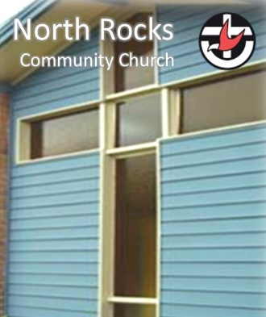
Revive
Restore
Reach Out
NEWSLETTER
7 February – 13 February 2022

NRCC News and Notices

▪ We have returned to face to face worship.
To keep everyone safe we have the following safety measures.
- Check in using our QR code. If this is not possible, please check in at the desk.
- Wear a mask while indoors.
- If you are feeling unwell, please consider others - stay away and get tested
- 1 person per 4 sqm indoors. Ensure 1.5m physical distancing where possible
- Singing is now allowed with a mask.
- At the end of the service please help by wiping down your chair
- We won’t be serving morning tea for now

If you are unable to join us at church, the message will be uploaded on Sunday afternoon to our YouTube Channel: https://www.youtube.com/channel/UC9XZ6bg-Sb5az1E9oqqPbFA.
It can also be accessed through our website: https://northrocks.uca.org.au/worship/

Community News and Notices

▪ NSW Floral Art Association - Floral Design Seminar

Members of the NSW Floral Art Association will be demonstrating Floral Design at NRCC Feb 18-19.

For a gold coin donation visitors can come to view the designs on Friday and Saturday 10am-12.30pm or visitors can watch the daily demonstrations for $25 per day.

For more information please go to https://nswfloralartassociation.org.au/

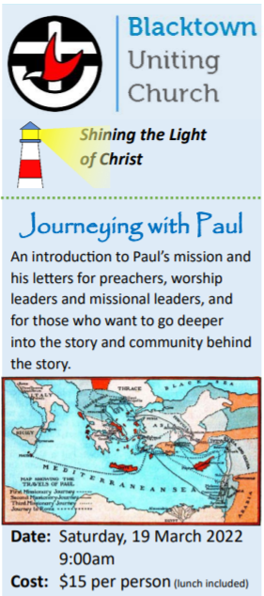
▪ “Journeying with Paul”

Blacktown UC’s next annual Biblical day “Journeying with Paul” is on Saturday 18 March.
We’ll be looking at Paul’s letters and mission. The focus will be twofold:
- How Paul’s creative and adventurous “make-it-up-as-you-go” mission in the 1st Century helps us figure mission out in the 21st Century.
- Lectionary passages from Paul’s letters and Acts from Easter onwards this year to help in preaching, worship-leading and Bible study.
Basic details:
- Saturday, 18 March.
- Blacktown Uniting Church.
- Arrive at 9.00 for a 9.30 start.
- Sessions run 9.30-3.30.
- Registrations essential by Tuesday, 15 March, please.
Click the link for the brochure for more information and all the practical details: eg cost (only $15 including lunch!), location, and most importantly, how to register.

https://microsites.uca.org.au/media/11897/journeying-with-paul.pdf

Reflection of the Week

This morning, when you got out of bed, did you look in the mirror? You probably took a shower, got dressed, brushed your teeth, and ran a comb through your hair. In other words, you took a good hard look at your reflection in the mirror and then took steps to change your appearance for the better.

The Lord's brother James said the Word of God is like a mirror. When we read the Bible, it exposes what is really in our hearts—our sins, our shortcomings, the areas of life where we need to repent. It's not always a pretty picture; most of us don't want to confront our hypocrisy, our compromises, our complacency. But when we do, God is able to do His merciful, loving work of transformation in our hearts.

The Bible is God's gift to us. He wants us to look more and more like Jesus each day. When we look at ourselves in the mirror of God's Word, we can see where we need to change—and we allow God to re-align our hearts with His. So today, when you pick up your Bible, look in the mirror—spiritually speaking—and allow your Heavenly Father to show you how you can look more like His Son.

Prayer: Jesus, I do long to be more like You, full of love, compassion, and kindness. May Your Word continue to transform me as Your Spirit renews my mind each day. Help me submit to Your will displayed in Scripture. I pray in the name of Jesus. Amen.

"Anyone who listens to the word but does not do what it says is like someone who looks at his face in a mirror and, after looking at himself, goes away and immediately forgets what he looks like" (James 1:23-24).

E - give (Direct Electronic Giving)  Account Name: North Rocks Community Church  (BSB): 634634 Account Number: 100025906 | Prayers  If you have any prayer requests or would like to know of those with particular pastoral needs to pray for, please contact Robyn, Steve or Pastoral Care Team.  Robyn: 0424791916
Ministry Leaders
Minister: Rev. Steve Lee / minister@northrocks.org.au / 0433 698 690
Church Council
Chairperson: Cathy Nelson Secretary: Jenny Keyte Treasurer: Anne Crabb
Team Leaders
Worship: Jenny Keyte Discipleship: Alex Chow Pastoral Care: Robyn Pike Fellowship: Sue Vasilevska
Intergen: Fiona & Cathy Mission: Steve Turner

North Rocks Community Church
132-136 North Rocks Rd, North Rocks. NSW 2151
https://northrocks.uca.org.au
Facebook: North Rocks Community Church
Email: enquiry@northrocks.org.au
Phone: (02) 9683 2586

Uniting Church in Australia https://uniting.church/
NSW & ACT Synod https://nswact.uca.org.au/
Parramatta Nepean Presbytery https://parramattanepean.uca.org.au/

