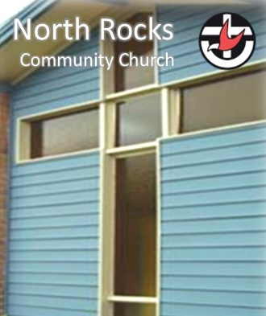
Revive
Restore
Reach Out
NEWSLETTER
21 March – 27 March 2022

NRCC News and Notices
▪ Lent Event calls you to join other Christians in a pledge to give up or take up something in solidarity with those who live with less. From 2 March to 14 April, Lent provides us with opportunities to reflect on our relationship with Christ and put faith into action.
For more information or ideas go to https://unitingworld.org.au/lent-event-is-coming/
Community News and Notices

▪ Moderator’s Flood Appeal to help devastated communities
The Uniting Church NSW/ACT has launched a special appeal to help those communities devastated by record-breaking floods.
https://nswact.uca.org.au/communications/newsroom/media-release-moderator-s-flood-appeal-to-help-devastated-communities/

▪ Resilience and the Human Spirit – Stations of the Cross 2022

April 1 – April 17. 10.00am - 4.00pm daily
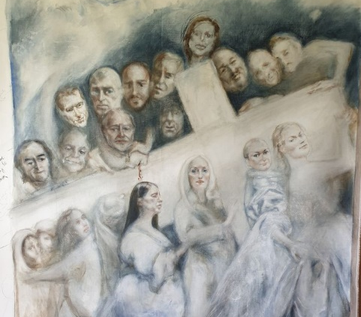
Exhibition Space, Northmead Creative and Performing Arts High School. Information: Northmead Uniting Church 9890 5814,
Northmead CAPAHS 02 96304116
https://www.facebook.com/NorthmeadSOTC

Since 2007 an annual exhibition has been curated as a fresh way for people to have a deep and rich experience of Easter. Over the past 8 years, the exhibition has grown and developed as a cooperative project of Northmead UCA and Northmead Creative and Performing Arts High School (CAPAHS.)

Each year we invite 15 major Australian artists to take 9 months to reflect on a short brief and then to create a particular artwork which we show in a joint exhibition. The artworks come into conversation with each other and invite the viewers to consider Easter texts in new and fresh ways. We want to provide an opportunity for people in the community to engage with some of the deeper life questions that are embedded in the Easter story.

The exhibition will be opened by Sr Rosemary Crumlin, the doyen of modern art and the religious imagination.

Exhibition Opening Monday 1st April - 6pm curatorial tour, 7.00pm Opening
Guided Tours 2.00 pm on weekend days or by appointment.
Wine and Cheese Night - Thursday 7th April at 7.00 pm
Eremos quiet half day Retreat Saturday 9th April from 10am-1.00 pm
Jazz Night Sunday 10th April at 6.00 pm
Good Friday Friday 15th April at 9.00 am

Reflection of the Week
Read Romans 12:1-8.

"Therefore, I urge you, brothers and sisters, in view of God's mercy, to offer your bodies as a living sacrifice, holy and pleasing to God—this is your true and proper worship" (Romans 12:1). In light of God's mercy toward us, Paul commands us to offer our lives to Him in worship. God has graciously given us everything we have, and acknowledging His tremendous love, we must give it all back to Him.

Worship is our only response to God's great mercy. It is our only response to His unbelievable, indescribable, unfathomable grace. It is the only way for us to appropriately express our gratitude and thanksgiving. And it is the secret to lasting contentment, joy, victory, and satisfaction.

Worship is meant to include every moment of our lives—not just on Sunday, but Monday through Saturday, too. True worship means daily dying to yourself and living for Christ. Wherever you go, there must go a living sacrifice, whether you are in the boardroom or on the factory floor, whether doing housework, parenting, or serving others. Living for God is a slow death of our pride, will, and self-sufficiency; that's why it's often more difficult to live for Jesus than to die for Jesus.

Your motive for giving your life to God must always be generated out of a response to His mercy toward you. True worship is not about what you can get from Him, but what you can give to Him. It's about showing God how much the mercy and grace He has lavished upon your soul means to you.

Prayer: Lord, thank You for lavishing Your love upon me and making me new. I want to be like You, Jesus, that You might receive honour and glory for resurrecting my dead heart and giving me eternal life. I pray in the name of Jesus. Amen.

"Do not conform to the pattern of this world, but be transformed by the renewing of your mind. Then you will be able to test and approve what God's will is—his good, pleasing and perfect will" (Romans 12:2).

E - give (Direct Electronic Giving)  Account Name: North Rocks Community Church  (BSB): 634634 Account Number: 100025906 | Prayers  If you have any prayer requests or would like to know of those with particular pastoral needs to pray for, please contact Robyn, Steve or Pastoral Care Team.  Robyn: 0424791916
Ministry Leaders
Minister: Rev. Steve Lee / minister@northrocks.org.au / 0433 698 690
Church Council
Chairperson: Cathy Nelson Secretary: Jenny Keyte Treasurer: Anne Crabb
Team Leaders
Worship: Steve Lee Discipleship: Alex Chow Pastoral Care: Robyn Pike Fellowship: Sue Vasilevska
Intergen: Fiona & Cathy Mission: Steve Turner

North Rocks Community Church
132-136 North Rocks Rd, North Rocks. NSW 2151
https://northrocks.uca.org.au
Facebook: North Rocks Community Church
Email: enquiry@northrocks.org.au
Phone: (02) 9683 2586

Uniting Church in Australia https://uniting.church/
NSW & ACT Synod https://nswact.uca.org.au/
Parramatta Nepean Presbytery https://parramattanepean.uca.org.au/

